Assessment 2

Requirements specification and design, due: noon, Spr/3/Mon (21st Jan)

Assessment 2 concerns the detailed software engineering design, and implementation of part of

the software system, based on the requirements and specification created for Assessment 1.

You will revisit the Assessment 1 deliverables, review and maintain non-code deliverables, and

apply version control.

Your group’s scenario (product brief) indicates which elements are to be designed and

implemented for Assessment 2. In Assessment 2, you must not exceed this brief: do not

implement any other features.

Your product must be consistent with the scenario, and with your Assessment 1 work, as

described below.

**Deliverables for Assessment 2**

Your team will submit a website plus a single .zip file. The requirements for the deliverables to be included in the zip file are summarised in Table 2.

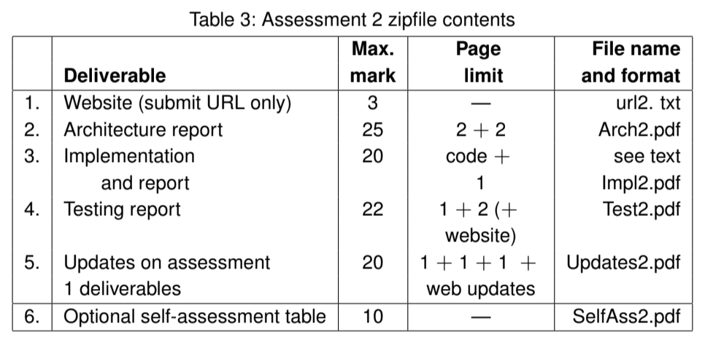

1. **Website [3 marks]:**
   1. all the project-related Assessment 2 deliverables, as well as the Assessment 1 versions (please note the specific requirements for updates, below);
   2. the executable for the game so far;
   3. your executable test plan and testing results for the game so far;
   4. the user manual for the game so far (including editable source as well as e.g. a pdf manual
2. **Architecture report [25 marks]:**
   1. Give a concrete architecture showing the structure of the team’s code, with a brief statement of the specific languages used to describe the architecture, and, if appropriate, the tool(s) used to create the concrete architecture representation. (15 marks, ≤ 2 page)
   2. Give a systematic justification for the concrete architecture, explaining how the concrete architecture builds from the abstract architecture – and any changes that had to be made to the abstract architecture. Relate the concrete architecture clearly to the requirements, using your requirements referencing for identification, and consistent naming of constructs to provide traceability. Provide precise URLs to any relevant web pages. (10 marks, ≤ 2 pages)
3. **Implementation [20 marks]:**
   1. Provide documented code for a working implementation of the part of the game that meets the remit, requirements and concrete architecture for Assessment 2. Code can be submitted in the zipfile, or via a link to a repository with a verifiable date before the hand-in deadline. (15 marks)
   2. State explicitly any of the features required for Assessment 2 that are not (fully) implemented, using your requirements referencing for identification, and consistent naming of constructs to provide traceability. Provide precise URLs to any relevant web pages. (5 marks, ≤ 1 pages)
4. **A software testing report [22 marks]:**
   1. Briefly summarise your testing method(s) and approach(es), explaining why these are appropriate for the project so far. (7 marks, ≤ 1 page)
   2. Give a brief report on the actual tests, including statistics of what tests were run and what results were achieved, with a clear statement of any tests that are failed by the current implementation. If some tests failed, explain why these do not or cannot be passed and comment on what is needed to enable all tests to be passed. If no tests failed, comment on the completeness and correctness of your tests instead. (5 marks, ≤ 2 pages)
   3. Provide the precise URLs for the testing material on the website: this material should comprise your testing design and evidence of testing, and is marked here (10 marks).
5. **Updates on assessment 1 deliverables [20 marks]:**

*In line with software engineering best practice, you are expected to maintain and update your assessment 1 deliverables, such that the up-to-date versions can be easily located on the team’s website. For assessment 2, the deliverable itself only requires summaries and the precise URLs, as follows:*

* 1. **Updated requirements [6 marks]:**
     1. On the Website, include the updated statement of requirements, highlighting what has been added and what has been changed (1 mark).
     2. In your deliverable, include a brief explanation and justification of any requirements

changes made for Assessment 2. Include the precise URL of the statement of updated requirements (≤ 1 page, 5 marks).*Please ensure that the original and any revised requirements referencing is clear, to support tracing of changes.*

* 1. **Methods, plans update [7 marks]:**
     1. On the website, include the updated plan, showing remaining key tasks, and detailed tasks for assessment 3. With the plan, include a brief explanation of any major changes. Also, include any updated documentation components — e.g. those originally provided under “Method selection and planning” in Assessment 1. (2 marks).
     2. In the deliverable, include a brief summary of any changes made in relation to the use of methods and tools, with a short explanation and justification of each. Give the precise URLs of the updated plan and any relevant methods and tools web pages (5 marks, ≤ 1 page).

*Note that you will be marked on the changes, explanations and justifications: please ensure that the changes are clearly highlighted.*

* 1. **Risk assessment and mitigation update [7 marks]:**
     1. On the website, include the updated risk assessment and mitigation, highlighting any changes that have been made. If you decided to change your approach to risk assessment and mitigation after Assessment 1, please state clearly that the web page content is new, and link to the Assessment 1 risk assessment to allow comparison (2 marks).
     2. In the deliverable, include a brief explanation and justification for any changes made to the risk assessment for the whole project; if you changed your approach, explain and justify your change. If no changes are made, explain why the risk assessment and mitigation, and the approach, are still appropriate. (5 marks, ≤ 1 page)

*Note that you will be marked on the changes, explanations and justifications: please*

*ensure that the changes are clearly highlighted.*

See Section 2 for information on the self-assessment table. [10 marks]

You may use additional pages for a bibliography. Any other overrun will be penalised.